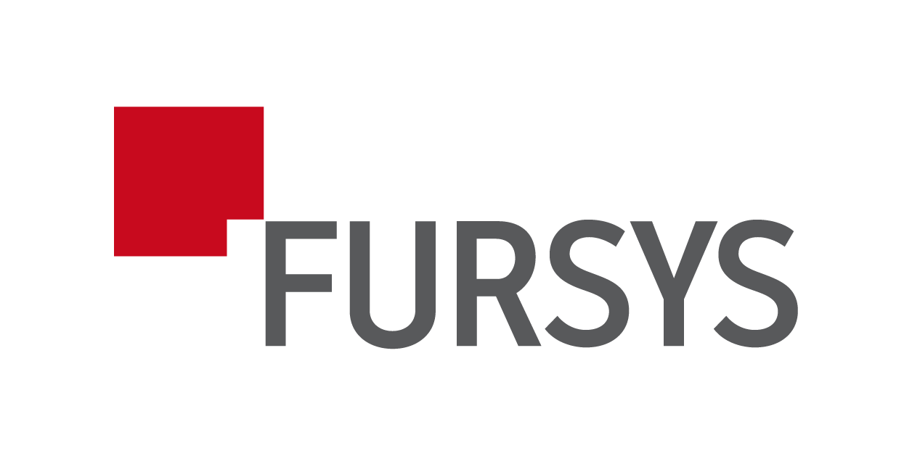
SUPPLY AGREEMENT
This Agreement is made and entered into by and between the following parties:
Supplier:
FURSYS INC.
FURSYS BLDG., 311, Ogeum-ro, Songpa-gu, Seoul, Republic of Korea
Website: http://www.globalfursys.com
Importer:
LX PANTOS VIETNAM LTD
[Address to be inserted]

Article 1 [Purpose]
This Agreement is intended to clearly define the terms under which the Supplier shall supply specified products to the Importer, and the Importer shall pay for such products.
Article 2 [Product and Quantity]
The Supplier shall deliver the products according to the attached item list. The details of items and quantities shall be based on attached item list.
Article 3 [Delivery and Incoterms]
1. The delivery deadline shall be by the end of July 2025.
2. Delivery shall be made under DDP terms as per Incoterms 2020 to the location designated by the Importer. The delivery location for the products listed in the attached item list shall be as follows:
[Insert Address]
3. The delivery schedule may be subject to delay due to unforeseen circumstances such as production issues or transportation problems. In such cases, the Supplier shall promptly notify the Importer and seek mutual agreement.
Article 4 [Payment Terms]
The Importer shall remit the payment as follows:
1. 100% before the release of the Bill of Lading (BL) (T/T remittance).
2. The total contract amount is [USD 66,131.2]. Upon full receipt of this payment, the Supplier shall release the Bill of Lading (BL) to the Importer.
3. The supplier will bear any income tax incurred from the contract amount. Importer bears VAT amount regulated by Vietnam withholding tax regulations if any
4. The Corporate Income Tax (CIT) component shall be borne by Supplier, and Importer shall be entitled to deduct and remit such CIT to the Vietnamese tax authorities on Supplier's behalf. Importer shall promptly provide Supplier with official tax payment receipts or certificates from the Vietnamese tax authorities for the CIT paid.
5. The Importer shall make the payment in USD by [0000].[00].[00].
6.Bank information for payment
[Bank name, Bank account, SWIFT Code]
Article 5 [Miscellaneous]
1. Any matters not specified in this Agreement shall be determined through mutual agreement between the parties.
2. In the event of any dispute arising in connection with this Agreement, the Seoul Central District Court shall have jurisdiction as the court of first instance. The governing law of this Agreement shall be the laws of the Republic of Korea.
This Agreement shall become effective upon the signatures of both parties after full understanding and agreement.
Date of Agreement: July.09, 2025
Supplier (FURSYS INC.) | Importer (LX PANTOS VIETNAM LTD)
Signature:  Name: Kwang-Ho, Park  Title: President  Date: July.09, 2025 | Signature:  Name:  Title:  Date:
Article 6 [List of Supplied Items and Total Amount]
The following table outlines the list of items to be supplied under this Agreement and their respective prices. The total contract amount shall be specified below.
[Table to be inserted upon finalization of product specifications and quantities]
Total Contract Amount: [USD 66,131.2]
1. Product price: USD 45,979.2
2. INSTALLATION FEE: USD 842.8
3. LOGISTICS COST: USD 2,610.4
4. TAX: USD 16,698.8

Article 7 [Termination]
1. Either Party (the Supplier or the Importer) shall have the right to immediately terminate this Agreement upon the occurrence of any of the following events:
(a) If a petition for bankruptcy, rehabilitation, or any similar insolvency proceeding is filed by or against the other Party;
(b) If the other Party fails to perform any of its obligations under this Agreement and does not cure such failure within two (2) weeks after receiving written notice requesting such cure.

Article 8 [Indemnification]
Any Party that breaches this Agreement shall indemnify, defend, and hold harmless the other Party from and against any and all losses, damages, costs, and expenses (including reasonable attorney’s fees) arising out of or relating to such breach.

APPENDIX.
ITEM LIST
